ULTRASONIC TESTING REPORT
Company/Client |  | NCOC N. V. |  | Project |  | ESKENE WEST |  | Location |  | Oil Tr1 Unit 210
Line No/Tag No: |  | A1-210-VA-116 |  | Material |  | A333 Gr.6 |  | Día × Nominal Thickness |  | 2”x5.54mm  6”x7.11mm
Procedure No: |  | QP-11-UTT-Q01 Rev 04  GOST 28702-90 |  | Calibration Block |  | Step wedge |  | Probe  S/N |  | D7908  1214571
 |  |  |  | Calibration block Range |  | 2.5-12.5 mm |  | Angle |  | 0º
Manufacturing Code |  | ASME B31.3 |  | Calibration Temp |  | +25ºC |  | Frequency |  | 7.5 MHz
 |  |  |  | Object Temp |  | +27ºC |  | Size |  | 5.1 mm
Acceptance Standard: |  | Acc. to the client specif. |  | Correction factors |  | n/a |  | Crystal |  | Dual
Surface condition |  | Coated |  | Couplant |  | UT Gel |  | Accuracy |  | ± 0,1 mm
S. No | Equipment/  Material Name |  | Manufacturer |  | Serial No |  | Calibration certificate No |  | Calibration Expiry date
 | DL-38 |  | OLYMPUS |  | 183107401 |  | BK-01-0079 |  | 05-02-2021
 | Step wedge calibration block |  | NDE-TECH |  | NDE-8365 |  | - |  | -
Job description:

- UT spot check performed on line A1-210-VA-116; A1-2101-PW-083-6”-A11-HC; A1-2101-PW-086-6”-A11-HC(drawing No: KE01-A1-PPKZ02A-B01-0004-000-PR15022; KE01-A1-PPKZ02A-B06-0004-PR15022).
- Echo to echo UT technique was used.
- Inspection performed on East, West, South, North, Top, Bottom and Extrados from external.
Notes:
N/A – not applicable.
FSH - Full Screen Height

Inspection drawing
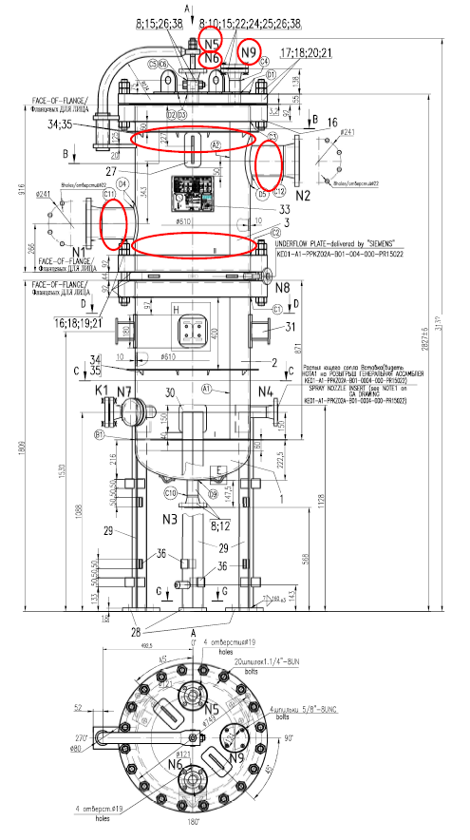
Shell-01
Shell-02
Nozzle N1
Nozzle N2
Nozzle N5
Nozzle N6
Nozzle N9
A1-210-VA-116
Inspection results
S/NO | Isometric No | Line No | Item description | DIA(Ø), inch | Nominal thickness, mm* | East  mm | West  mm | South  mm | North  mm | Top  mm | Bottom  mm | Extrados  mm
1 | KE01-A1-PPKZ02A-B01-0004-000-PR15022 | A1-210-VA-116 | Shell-01 | 749mm | 10 | 10.53 | 10.68 | 10.63 | 10.61 | - | - | -
2 | KE01-A1-PPKZ02A-B01-0004-000-PR15022 | A1-210-VA-116 | Shell-02 | 749mm | 10 | 10.58 | 10.60 | 10.55 | 10.65 | - | - | -
3 | KE01-A1-PPKZ02A-B01-0004-000-PR15022 | A1-210-VA-116 | Nozzle N1 | 6” | 8.74 | 8.76 | 8.40 | - | - | 8.71 | 8.56 | -
4 | KE01-A1-PPKZ02A-B01-0004-000-PR15022 | A1-210-VA-116 | Nozzle N2 | 6” | 8.74 | 8.70 | 8.66 | - | - | 8.68 | 8.75 | -
5 | KE01-A1-PPKZ02A-B01-0004-000-PR15022 | A1-210-VA-116 | Nozzle N5 | 2” | 7.14 | 8.51 | 9.04 | 8.59 | 9.15 | - | - | -
6 | KE01-A1-PPKZ02A-B01-0004-000-PR15022 | A1-210-VA-116 | Nozzle N6 | 2” | 7.14 | 8.80 | 8.71 | 9.04 | 8.85 | - | - | -
7 | KE01-A1-PPKZ02A-B01-0004-000-PR15022 | A1-210-VA-116 | Nozzle N9 | 2” | 7.14 | 9.04 | 8.86 | 8.61 | 8.83 | - | - | -

Inspection drawing
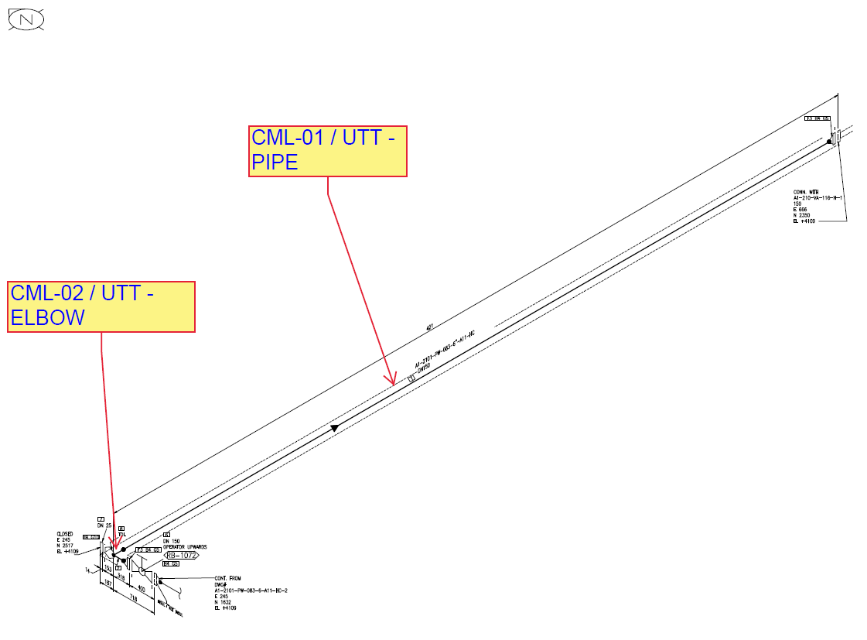
KE01-A1-PPKZ02A-B06-0004-PR15022/ A1-2101-PW-083-6”-A11-HC
Inspection results
S/NO | Isometric No | Line No | Item description | DIA(Ø), inch | Nominal thickness, mm* | East  mm | West  mm | South  mm | North  mm | Top  mm | Bottom  mm | Extrados  mm
1 | KE01-A1-PPKZ02A-B06-0004-PR15022 | A1-2101-PW-083-6”-A11-HC | CML-01 | 6 | 7.11 | 7.04 | 8.20 | - | - | 7.04 | 7.07 | -
2 | KE01-A1-PPKZ02A-B06-0004-PR15022 | A1-2101-PW-083-6”-A11-HC | CML-02 | 6 | 7.11 | - | - | - | - | 7.54 | 6.92 | 6.66

Inspection drawing
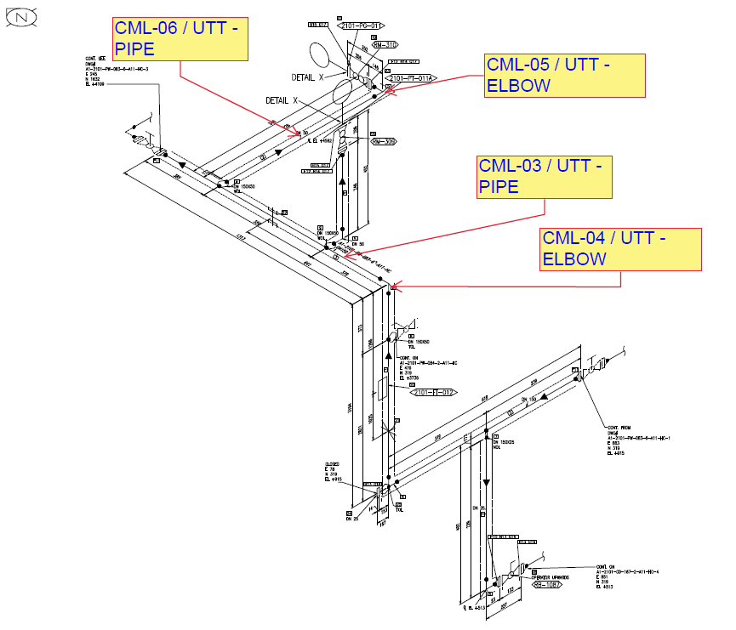
KE01-A1-PPKZ02A-B06-0004-PR15022/ A1-2101-PW-083-6”-A11-HC
Inspection results
S/NO | Isometric No | Line No | Item description | DIA(Ø), inch | Nominal thickness, mm* | East  mm | West  mm | South  mm | North  mm | Top  mm | Bottom  mm | Extrados  mm
1 | KE01-A1-PPKZ02A-B06-0004-PR15022 | A1-2101-PW-083-6”-A11-HC | CML-03 | 6” | 7.11 | - | - | 7.29 | 7.06 | 7.07 | 7.25 | -
2 | KE01-A1-PPKZ02A-B06-0004-PR15022 | A1-2101-PW-083-6”-A11-HC | CML-04 | 6” | 7.11 | - | - | 6.99 | 7.54 | - | - | 6.56
3 | KE01-A1-PPKZ02A-B06-0004-PR15022 | A1-2101-PW-083-6”-A11-HC | CML-05 | 2” | 5.54 | - | - | - | - | 5.91 | 5.96 | 5.67
4 | KE01-A1-PPKZ02A-B06-0004-PR15022 | A1-2101-PW-083-6”-A11-HC | CML-06 | 2” | 5.54 | 5.67 | 5.84 | - | - | 5.54 | 5.43 | -

Inspection drawing
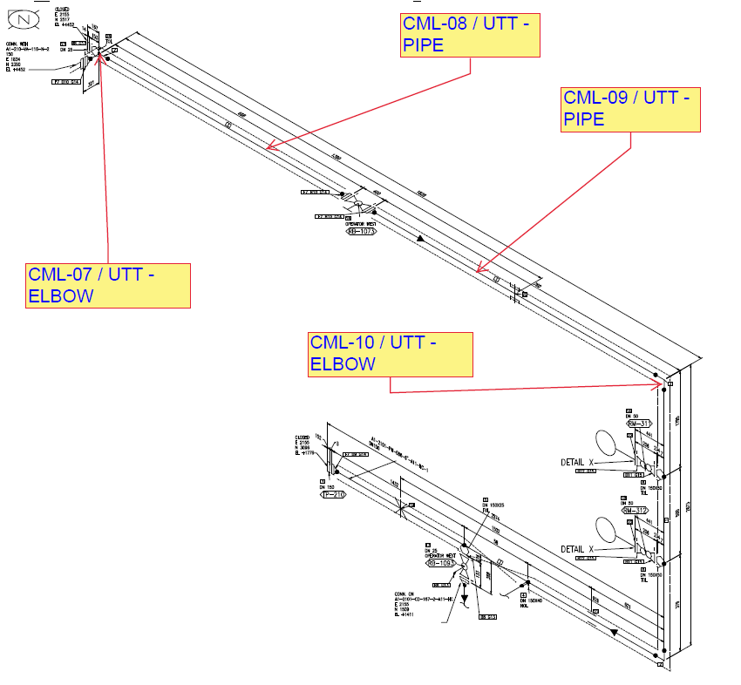
KE01-A1-PPKZ02A-B06-0004-PR15022/ A1-2101-PW-086-6”-A11-HC
Inspection results
S/NO | Isometric No | Line No |  | Item description | DIA(Ø), inch | Nominal thickness, mm* | East  mm |  | West  mm | South  mm | North  mm | Top  mm |  | Bottom  mm | Extrados  mm
1 | KE01-A1-PPKZ02A-B06-0004-PR15022 | A1-2101-PW-086-6”-A11-HC |  | CML-07 | 6” | 7.11 | - |  | - | - | - | 7.22 |  | 7.05 | 6.41
2 | KE01-A1-PPKZ02A-B06-0004-PR15022 |  |  | CML-08 | 6” | 7.11 | - |  | - | 7.21 | 7.63 | 7.34 |  | 7.60 | -
3 | KE01-A1-PPKZ02A-B06-0004-PR15022 |  |  | CML-09 | 6” | 7.11 | - |  | - | 7.37 | 7.26 | 7.17 |  | 7.57 | -
4 | KE01-A1-PPKZ02A-B06-0004-PR15022 |  |  | CML-10 | 6” | 7.11 | - |  | - | 7.38 | 7.44 | - |  | - | 6.78
Examined by  UT L II cert. No 1400  expiry date: 31.01.2023 |  |  | Name: Tolegenov Alimzhan |  |  |  |  | Signature: ............................... |  |  |  |  | Date: 05 Spt 2020
Approved by:  UT L II cert. No 2B 421/20  expiry date 31.07.2025 |  |  | Name: Shakunou Andrei |  |  |  |  | Signature: ........................... |  |  |  |  | Date: 05 Spt 2020
Client Representative: |  |  | Name: …………………………… |  |  |  |  | Signature: .............................. |  |  |  |  | Date: ……………………

